California Science Test (CAST)- Sample Practice Test

Step 1: Type in the URL: http://www.caaspp.org/
Step 2: Select “Practice & Training Tests”

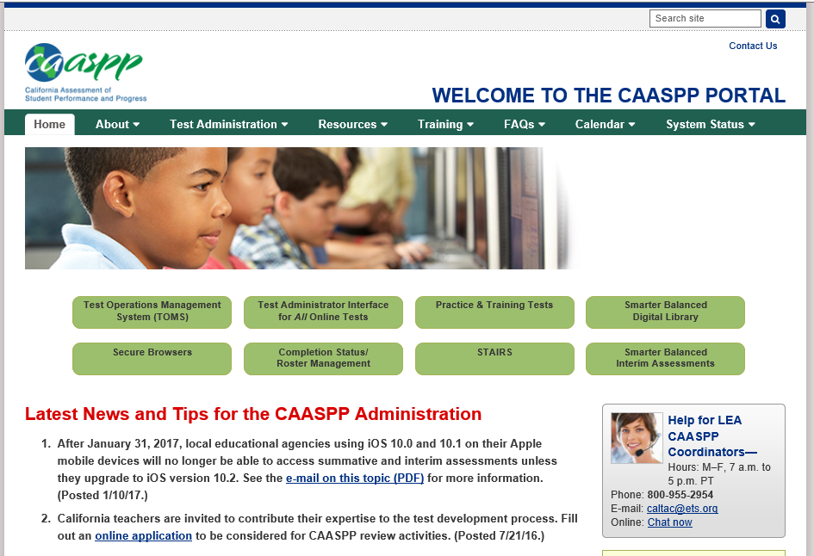

Step 3: Select “Student Interface Practice and Training Tests”
Note: The other options provide instructions on how to administer the test.

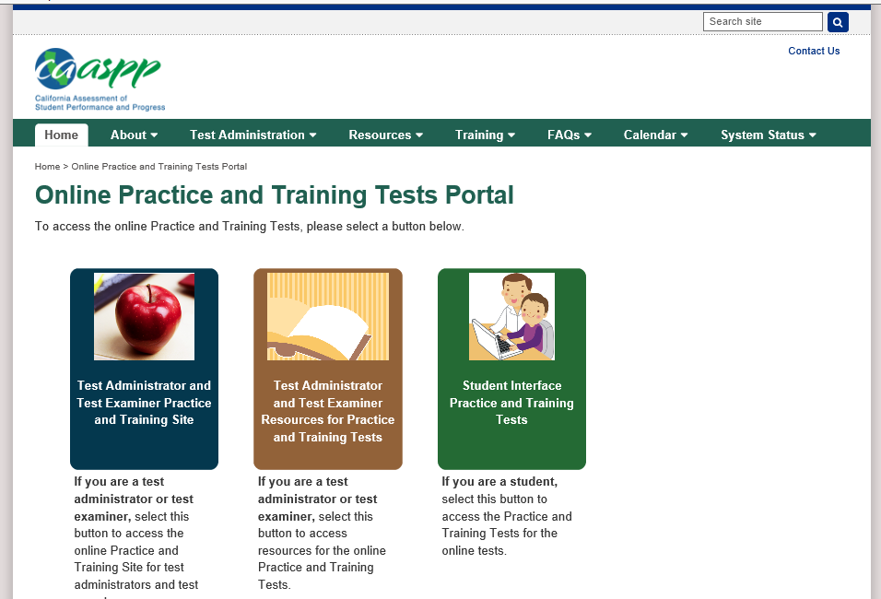
Step 4: Click the “Sign In” button without typing anything in the fields.
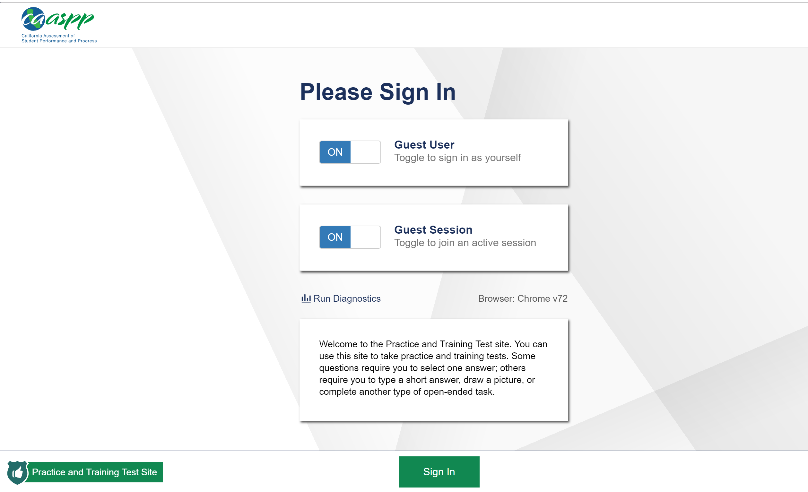

Step 5: Click the “Grade” dropdown menu. Select the level or band relevant to your course.
Note: Select 5, 8, or High School, based on which grade band you fall into. Other grades will not appear.
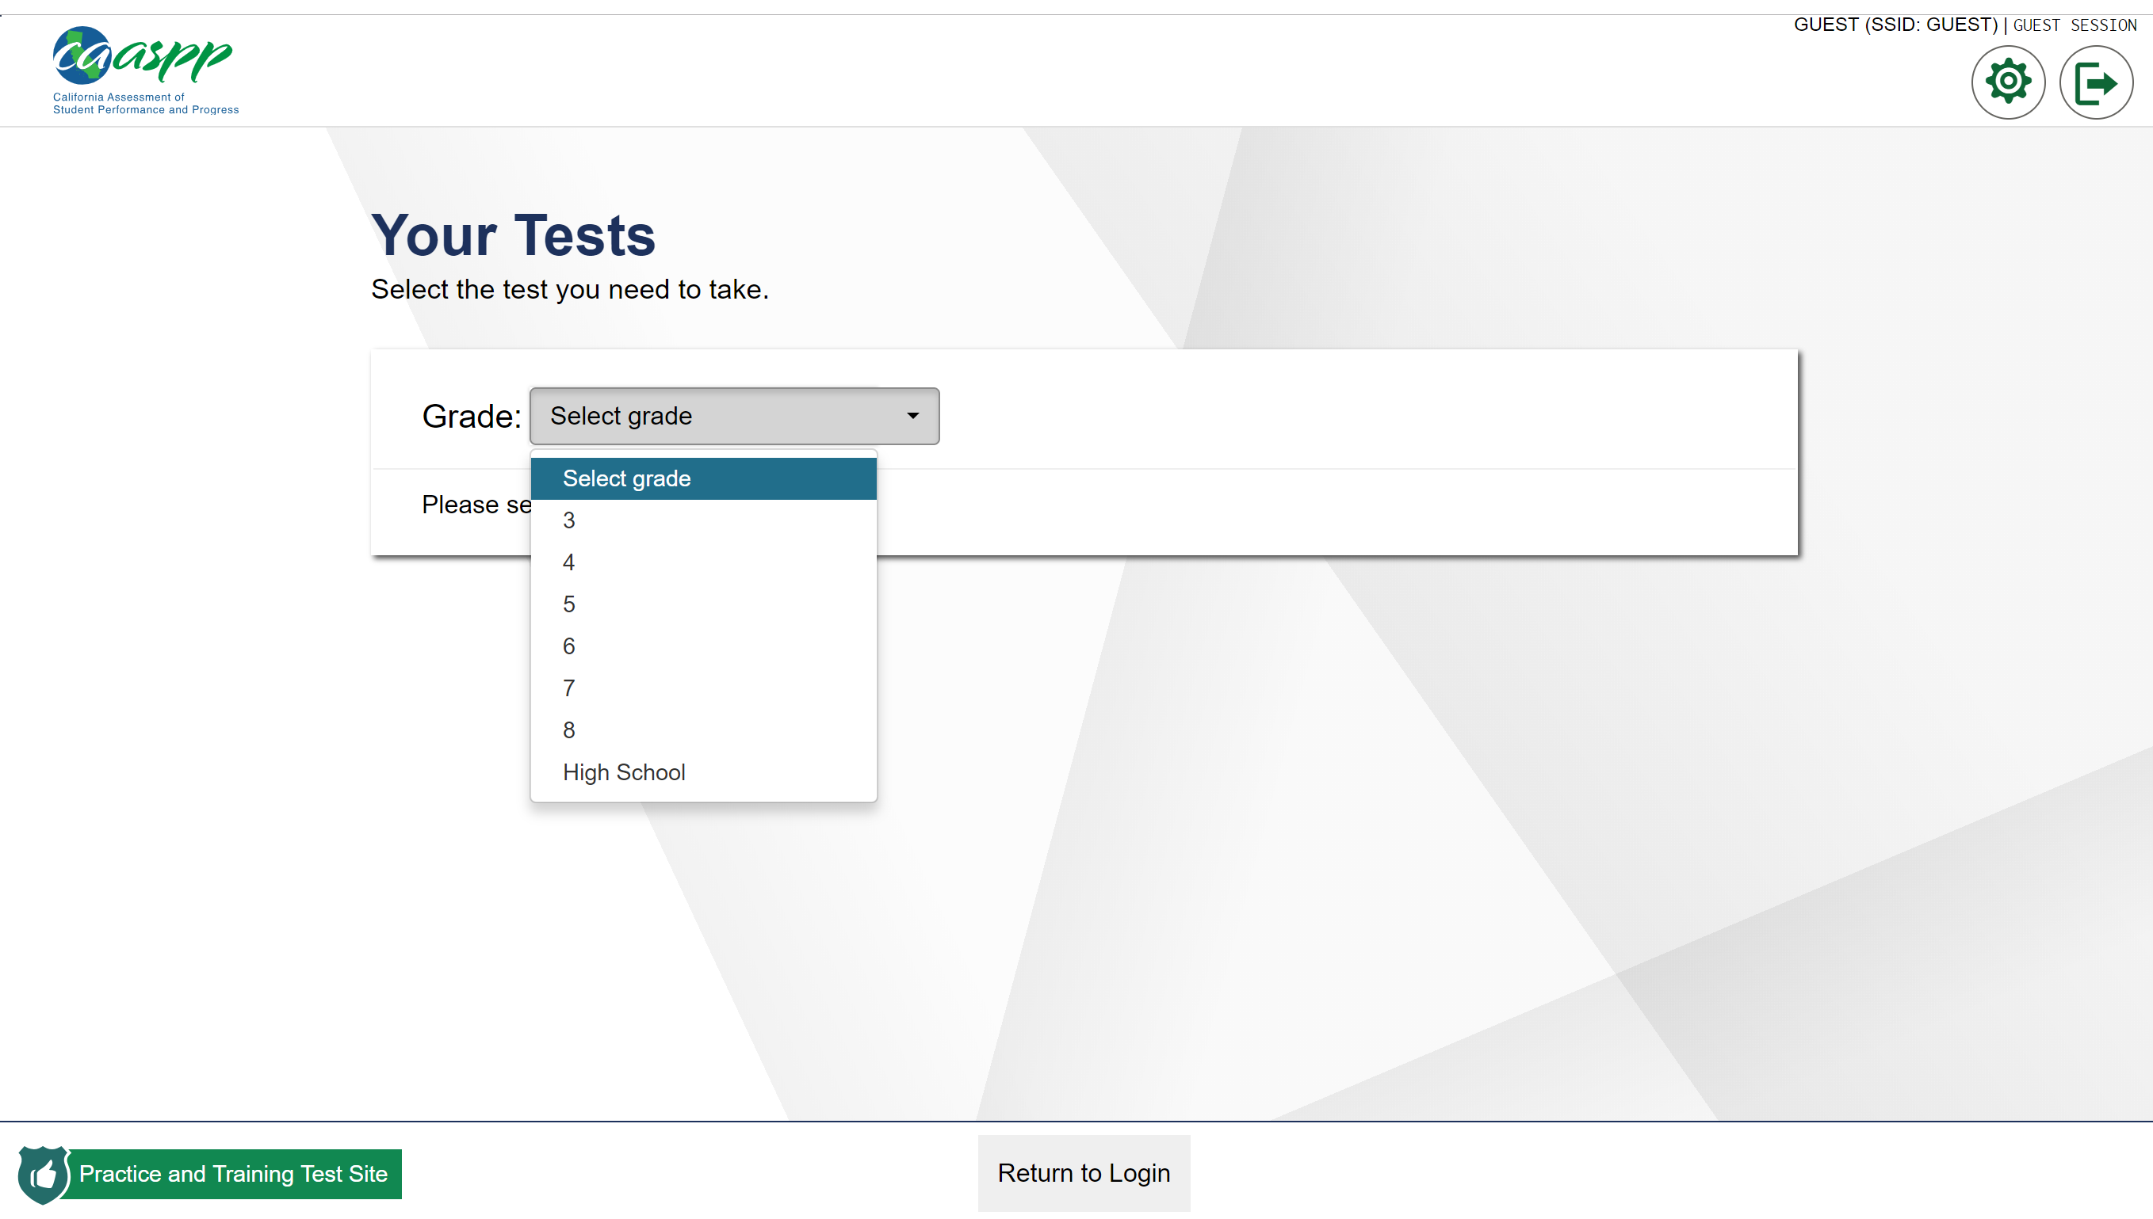

Step 6: Scroll to the bottom of the screen and select the grey “California Science (CAST) Practice Test” for the most recent released questions.
Note: You can also select the orange “California Science Test (CAST) Training Test” for additional practice questions, but this version is shorter so start with the grey.
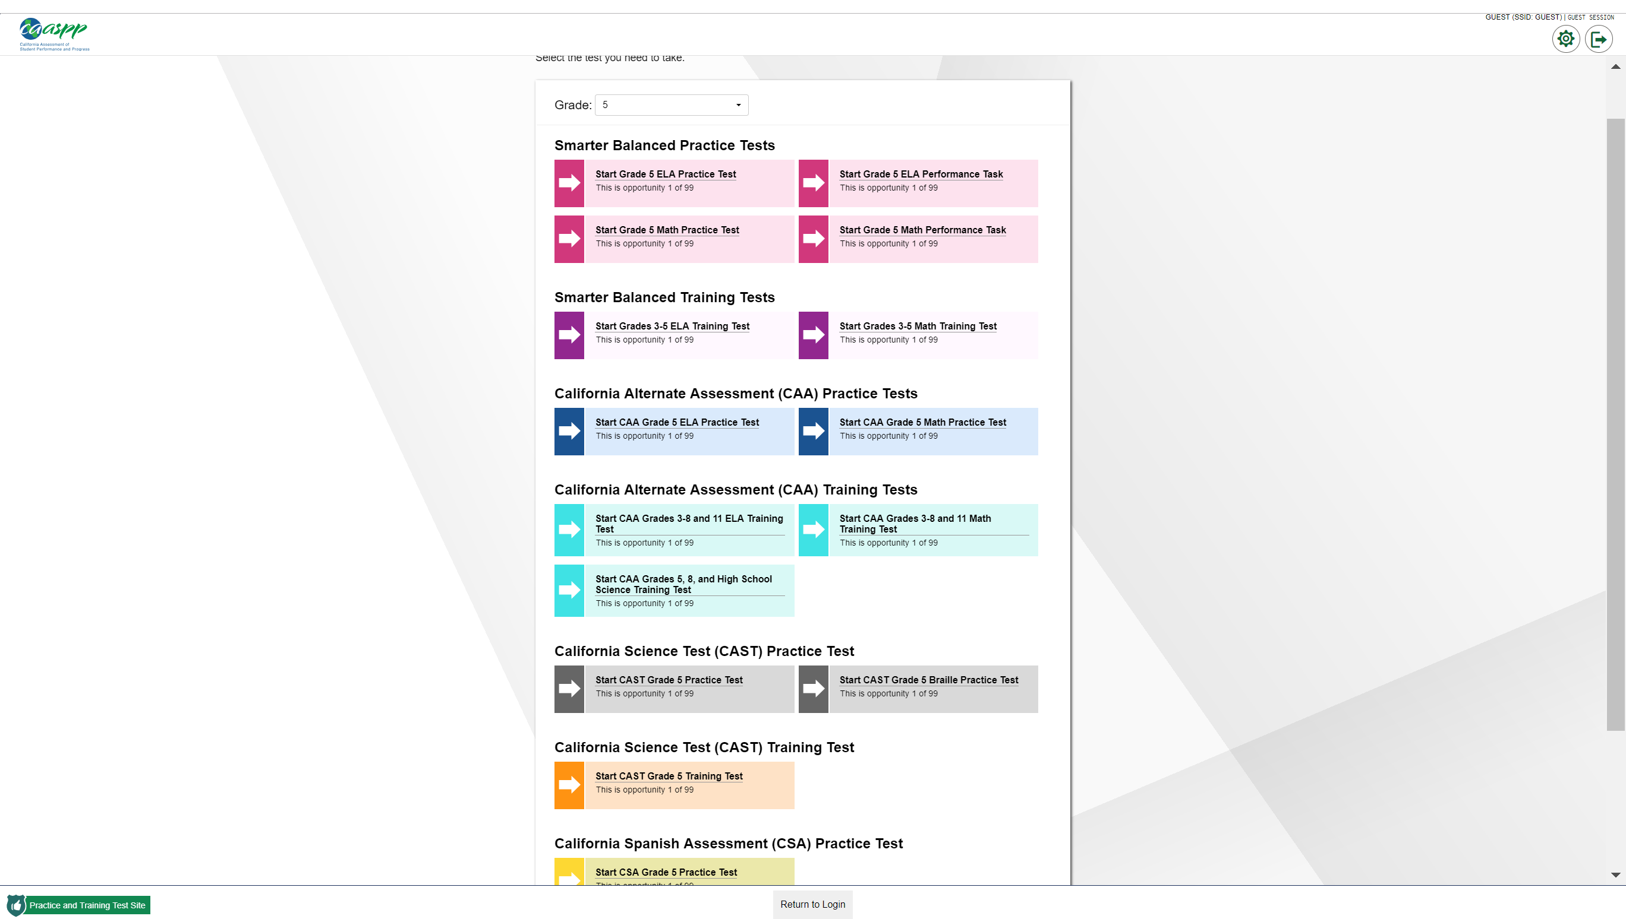

Step 7: Select the dropdown options of your choosing, then click “Select” to move on. You can also leave the dropdown choices blank and just hit, “select” to move on.
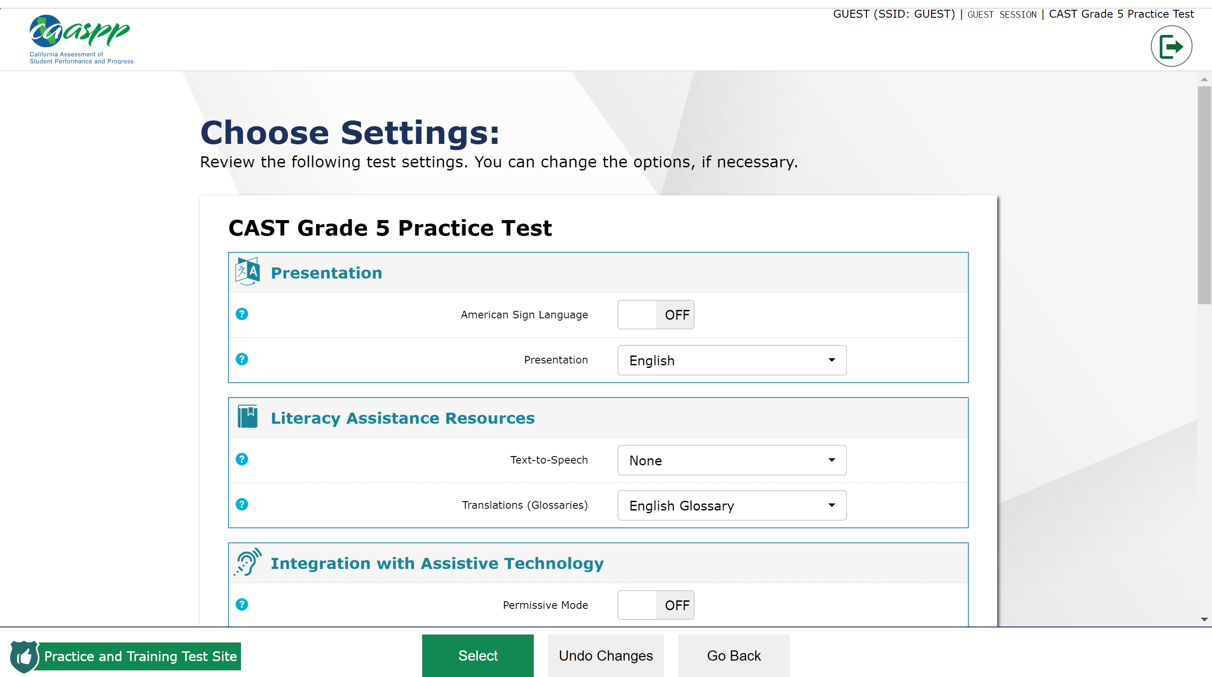

Step 8: Play the video to test your computer’s sound, then click “I could play the video and sound” followed by “continue”. Adjust your computer settings as needed.
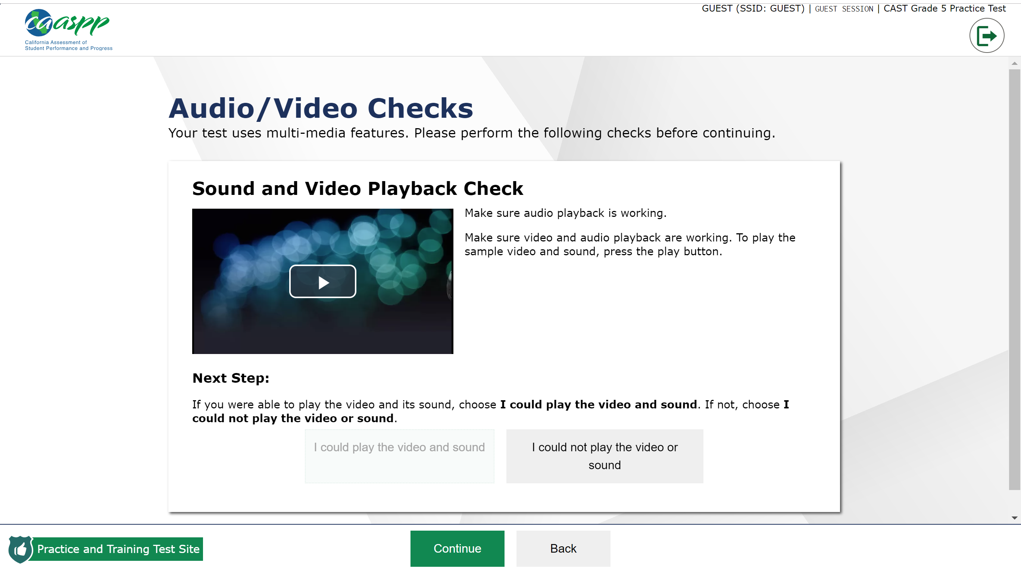

Step 9: Select “View Help Guide” to read through navigation tools in this platform. Spend time here with students so that they know all of the resources that are available, and how to access them. When finished,
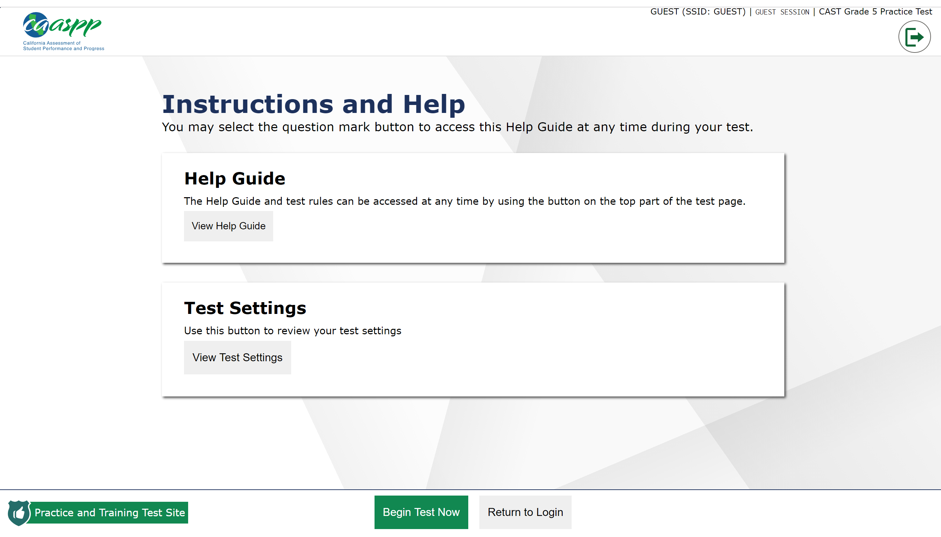
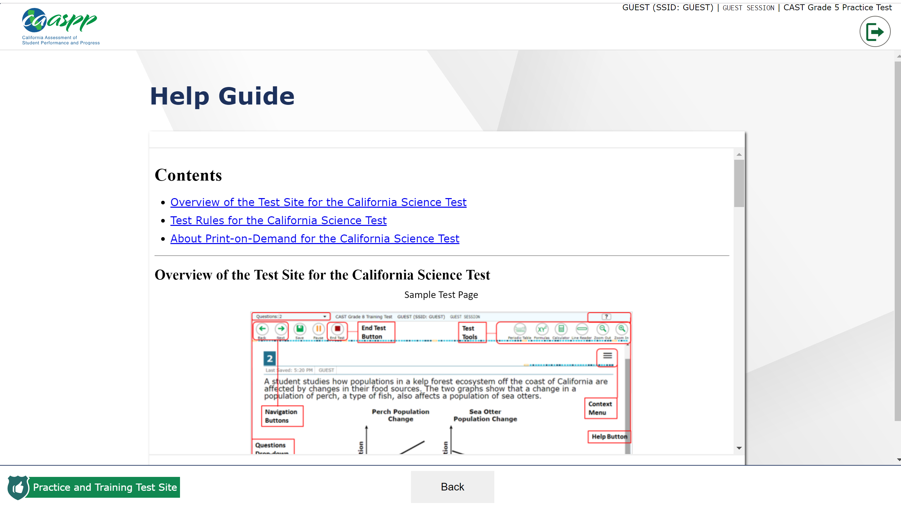

Step 10: Once finished reviewing the Help Guide, click on the “Back” button at the bottom center of the screen to access the practice questions.
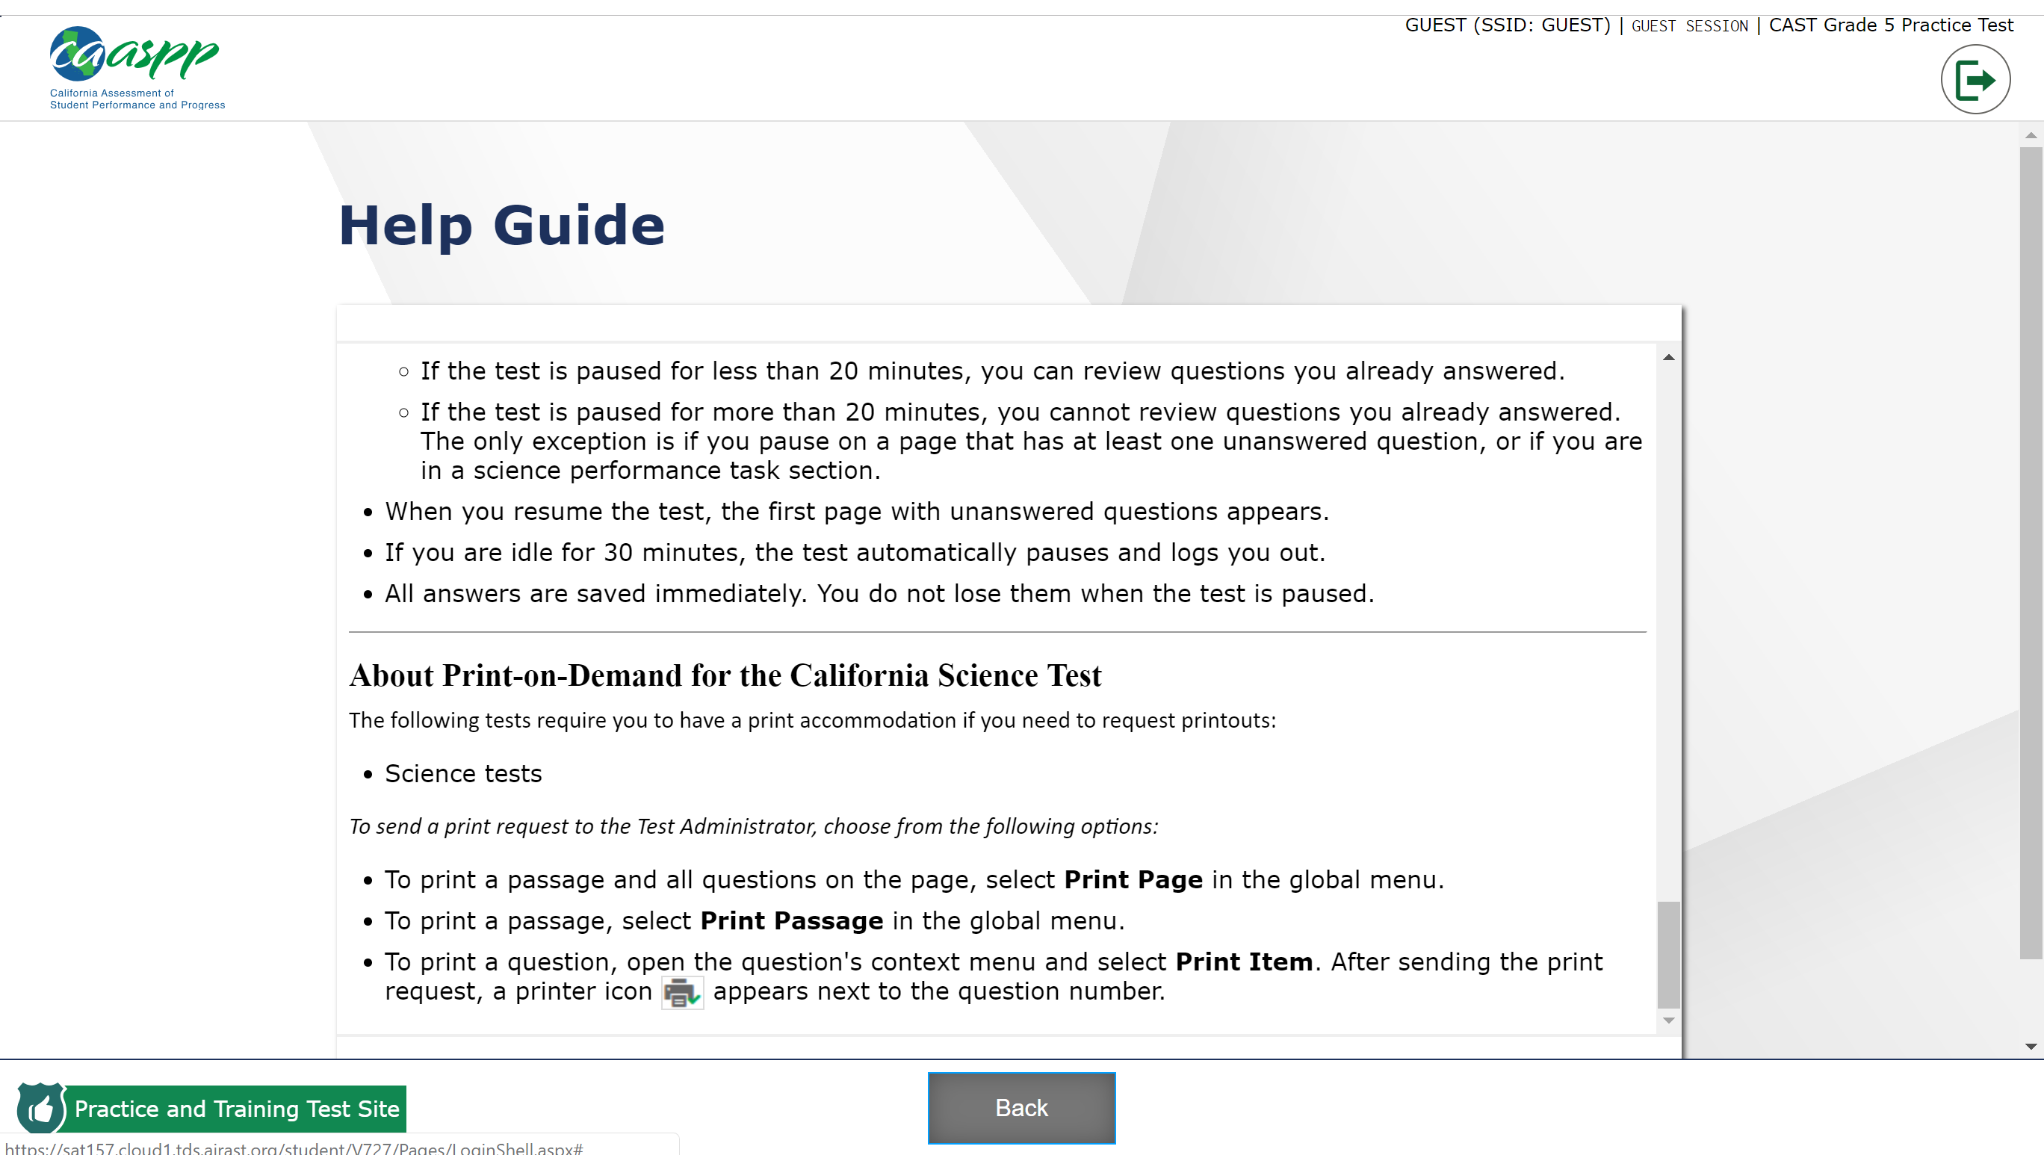

Step 11: (Optional) If accommodations are needed for a student, select “View Test Settings” to change setting options.
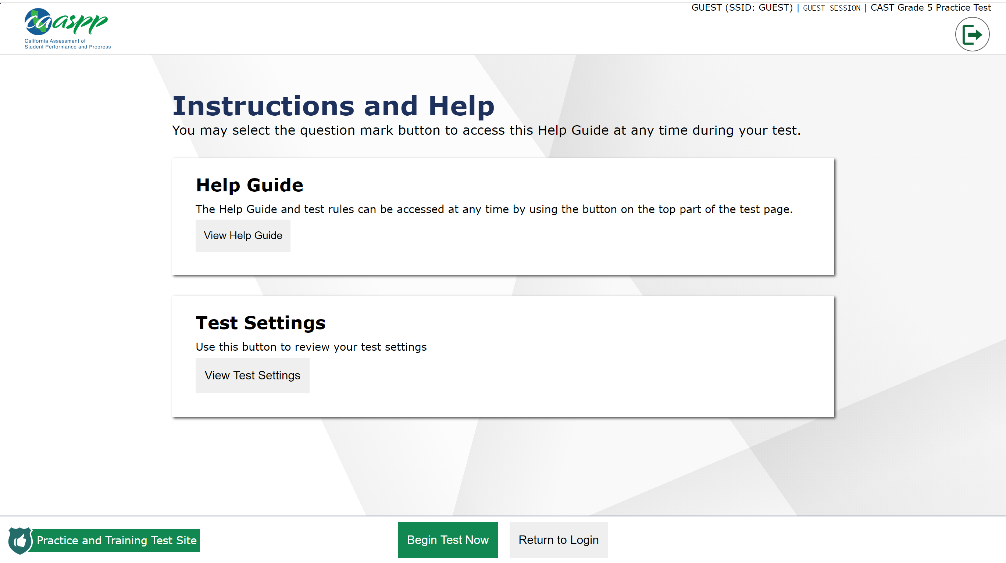

Step 12: (If Step 11 was used) Change setting options as needed. When finished, select “Ok” to return to the previous page.

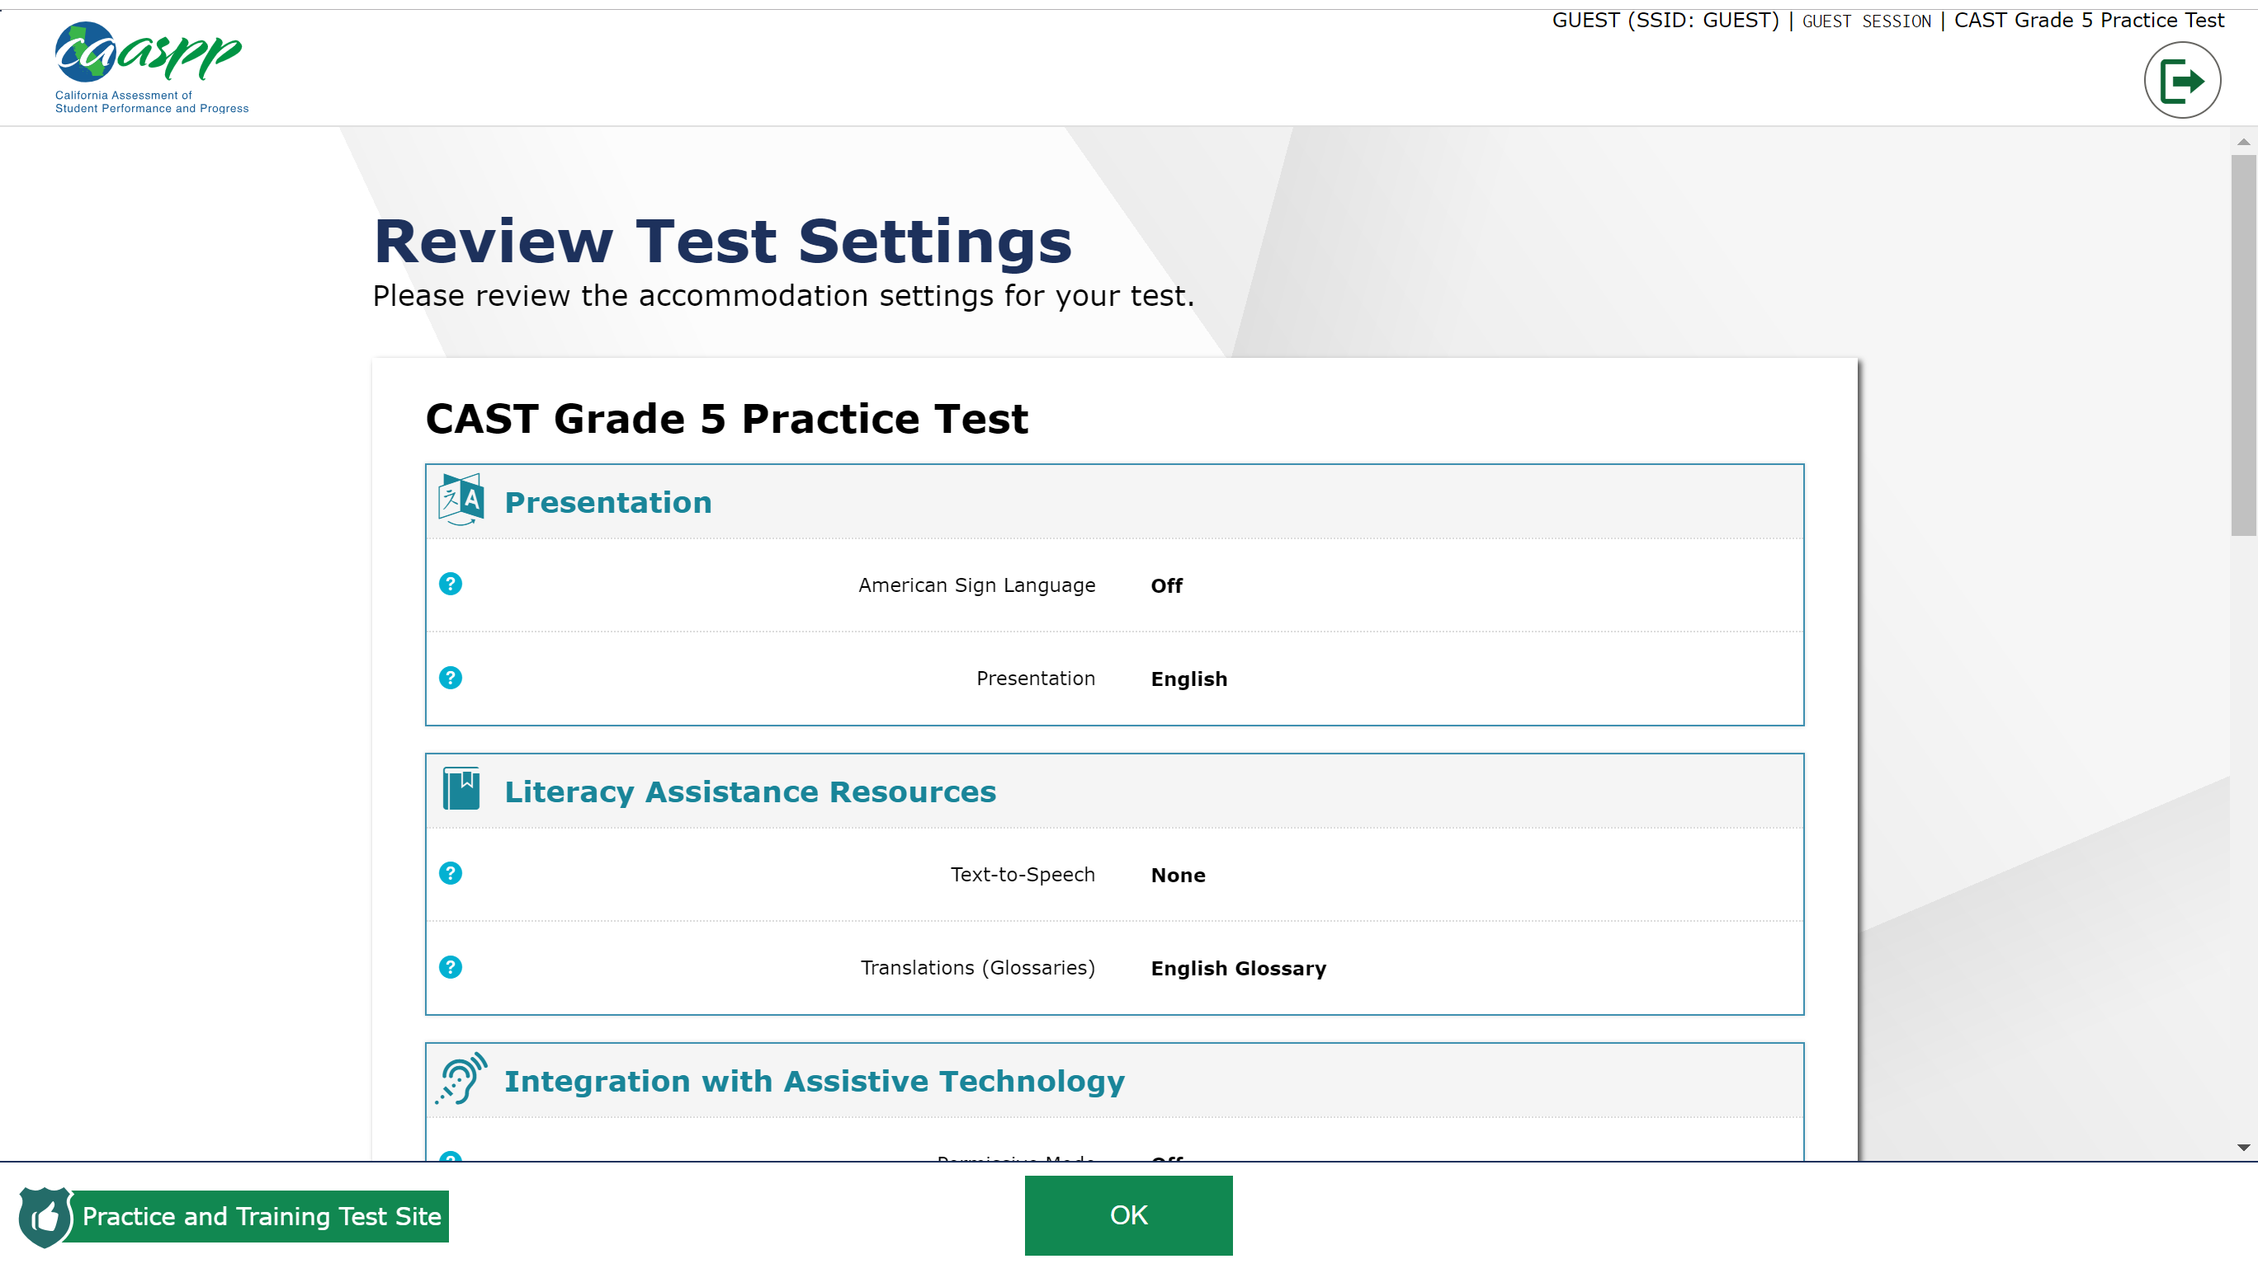

Step 13: Select “Begin Test Now” to start the practice test.
Note: To progress through the practice questions, you must select “next” in the top left corner of the screen. An answer must be provided before progressing to the next page.

